# **­­­­­Main Activity**

We the members of Group $ have come up with ideas to improve learning in the home Economics Department ………………

List of Technologies used

HTML, CSS, Bootstrap, JavaScript, Etc.

# **Specification**

1. Which fonts will we be using (Choose at most two) ____________
2. Poppins
3. MTN Brighter Sans
4. Rubik
5. Segoe UI
6. Soliel
7. Roboto
8. Gotham-Rounded
9. Svelte
10. Geometric-Sans
11. Which colour scheme will we be using? _________________
12. Discreet Scheme

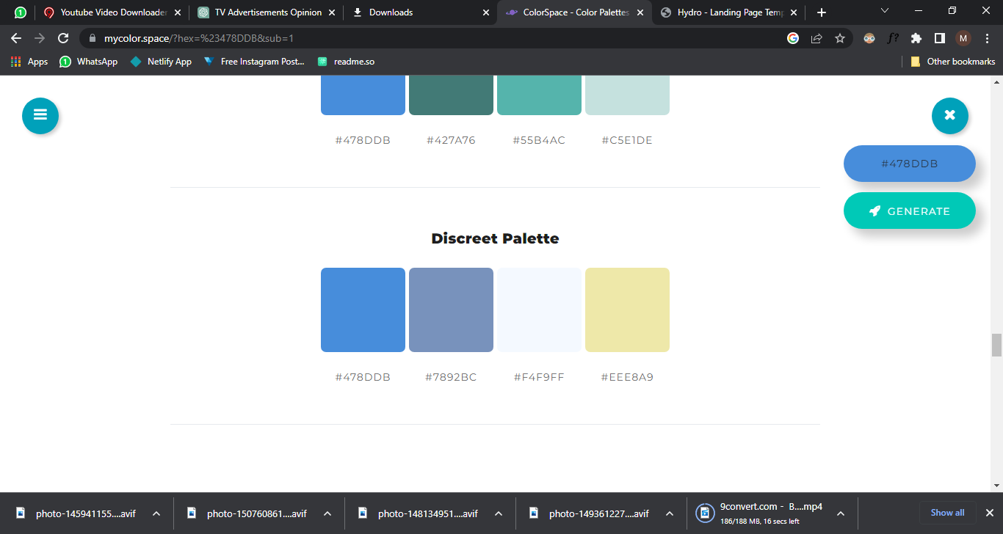

1. Dust Scheme

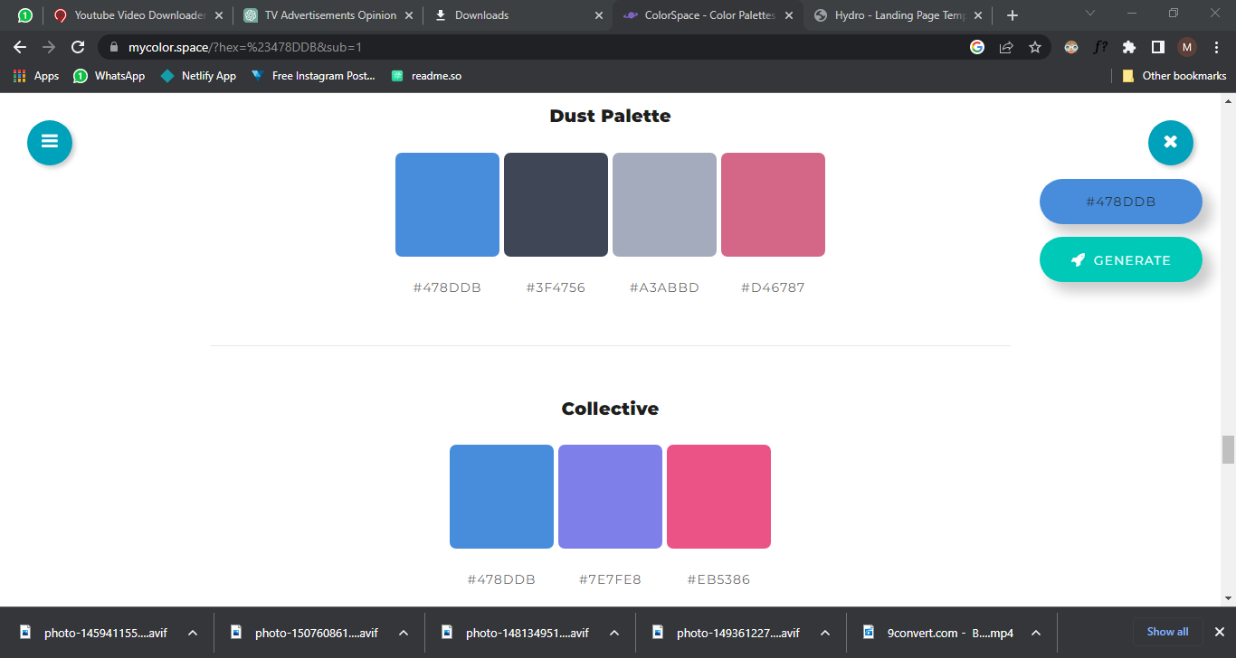

1. Collective



1. What will be the website style?
2. Casual
3. Formal
4. Simple
5. Immersive / Interactive